Lab1 Demo Submission: Zenmap
(The goal of this document is to show you a rubric, or what is expected from you to submit in lab assignments). You can use this sample for all class labs. This demo reflects my expectations from you when you submit a lab assignment, in order to get a full grade
Introduction
- Latest version of Kali Linux can be downloaded from their official website
https://www.kali.org. As I am going to use it as a virtual OS, through Oracle Virtual Box, I decided to use an already built virtual box from the website (http://www.osboxes.org/kali-linux/). From this website, I downloaded: VirtualBox (VDI) 32bit Download Size: 3.4GB. This image(based on the website) has the user name: root and the password osboxes.org
- After completing the download, I created an image in virtual box for the image disk that I downloaded

- I noticed that their was an issue with the image (where I cant update or install tools properly), so I updated the file (sources.list) in Kali (sudo gedit /etc/apt/sources.list) according to the original lists described in Kali website (http://docs.kali.org/general-use/kali-linux-sources-list repositories) 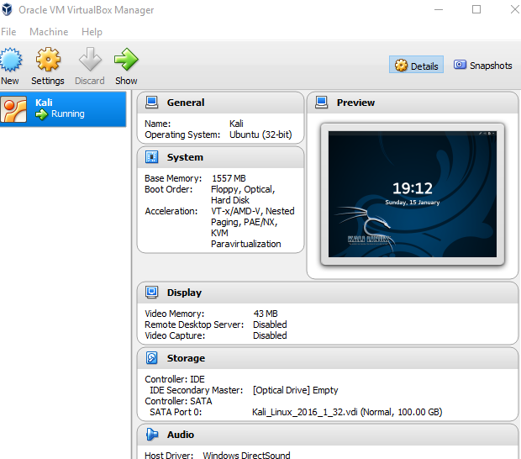
- Zenmap is a GUI version of NMAP network scanner (which is largely used as port scanner/mapper)
- It can be called in Kali by its name (zenmap)
- Port scanning is used by hackers in early stages to know about open ports and based on that try to attack the network. For Pen testers, its also used to make sure that only relevant ports are open
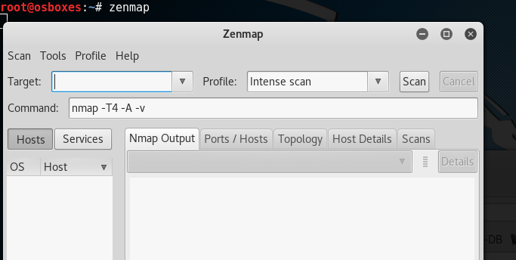
- The tool uses nmap console commands, for example, we select a host and start intense scan, the console command will be nmap –T4 –A –v www.yahoo.com
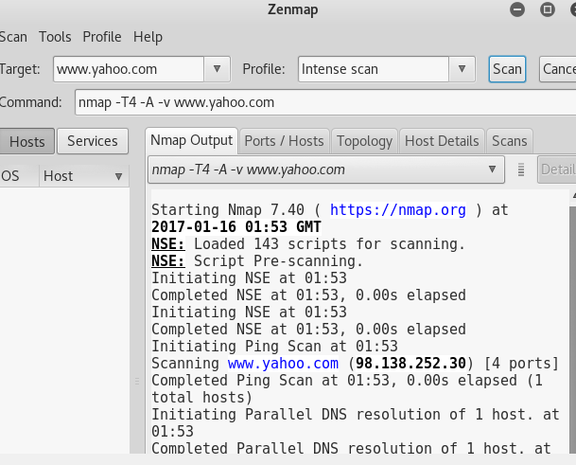
- The first information we extract from the tools is the TCP/UDP ports’ status (i.e. either open, filters, or closed)
- Some commands can give more time in testing ports ( as TCP and UDP each has 64K ports, some tasks can take time)
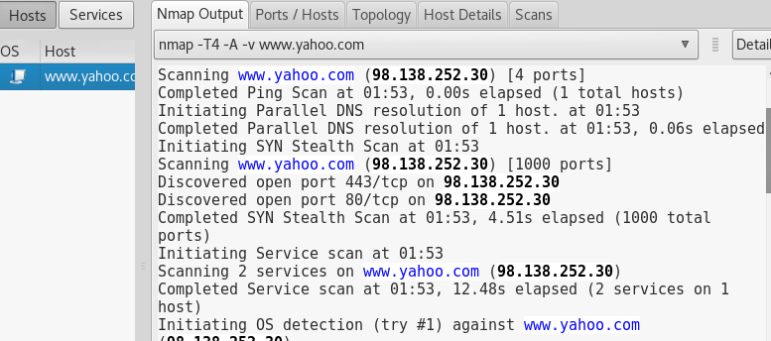
- We care more about open ports (as typically limited number of ports should be opened)
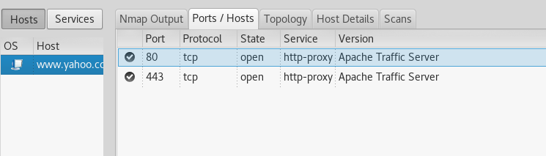
- For the least the host should have 80 open (to enable Internet)
- We can get more details in the hosts or services of the tested domain
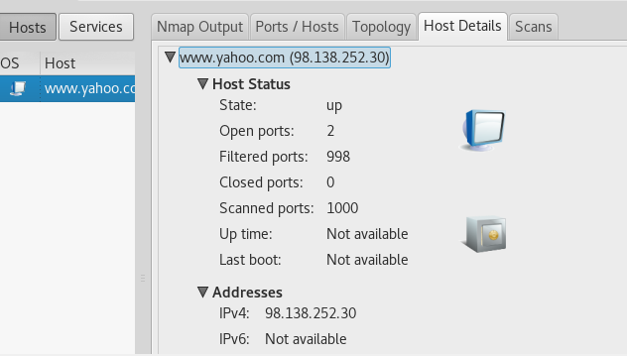
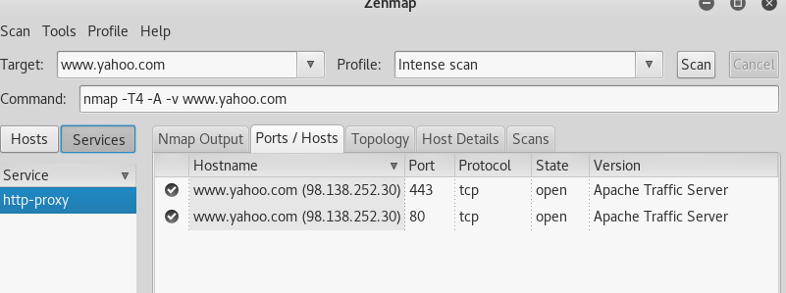

What you will do ? Make your own demo and screenshots of Zenmap tool (For simplicity, you can follow the steps describe in one the following two links, either one is fine)
https://www.youtube.com/watch?v=dlcx-fmzrnc
https://www.youtube.com/watch?v=0uGyMpUdKpU
https://nmap.org/book/zenmap.html

